N-Acetylmuramic Acid (NAM) — Complete Analysis Report
Sample & Instrument Specs · Old vs. New Powder Raman · α- vs. β-Anomer DFT · Literature · SERS Validation
Compiled 28 August 2026 · companion to the NAM_Master_Dataset consolidated folder
What this report covers
- The sample, Raman instrument, and DFT compute specifications behind every number in this study.
- The two powder Raman datasets — the OLD April optimisation grid and the NEW May replicate set the reference spectrum is built from — and how they relate.
- The two DFT anomer simulations (α and β) and the rigorous statistical test of whether the α-anomer explains bands the β-anomer misses.
- Powder-vs-DFT peak matching and cross-check against published literature.
- The full SERS story: substrate selection, powder-vs-SERS comparison, and step-by-step validation ending in a matched-blank-substrate test.
- A data-quality note on a discrepancy found in the archive, and where everything now lives.

1. Sample and Machine Specifications

1.1 Sample
Property | Value
Compound | N-Acetylmuramic acid (NAM, MurNAc)
Supplier / catalogue | Sigma-Aldrich (Merck), A3007-100MG
CAS / Lot | 10597-89-4 / BCCK5768
Formula / MW | C₁₁H₁₉NO₈ / 293.27 g/mol (anhydrous)
Purity | ≥98% (TLC), synthetic, no purification
Anomeric configuration | NOT specified by supplier — α/β mixture (normal for a reducing sugar)

1.2 Raman instrument
Property | Value
System | B&W Tek i-Raman Plus, BWS465-785H
Laser | 785 nm, Class 3B, 0–100% in 1% steps
Power budget | 495 mW safety label → 455 mW at port → 340 mW exiting probe → at-sample power unmeasured
Detector | 2048-pixel TE-cooled CCD (−20 °C)
Resolution | < 3.5 cm⁻¹ (manufacturer spec)
Analysis window | 400–1800 cm⁻¹, 1 cm⁻¹ grid

1.3 DFT compute
Property | Value
Software | Gaussian 16, Revision C.01 (Windows 64-bit)
Method / basis | B3LYP-D3BJ / 6-311++G(d,p)
Phase | Gas phase, isolated molecule, no solvation
Resources | 16 shared-memory processors, 48 GB RAM
β-anomer runtime | 3h 42m opt + 58m freq ≈ 4h 41m
α-anomer runtime | 2h 39m opt (27 steps) + 1h 03m freq = 3h 42m
Imaginary frequencies | 0 for both anomers — both are true minima

2. Powder Raman — Old (April) vs. New (May) Data
Two powder Raman datasets exist, collected roughly five weeks apart, and they serve different purposes rather than being a simple do-over.

2.1 OLD — April Optimisation Grid (98 spectra, 20–24 April)
A systematic grid of 5 integration times (5–25 s) × 16 power levels (5–80%), one spectrum per condition. This is not a replicate set — every spectrum is a different acquisition condition, collected to find a safe, high-quality setting before committing to a measurement campaign.
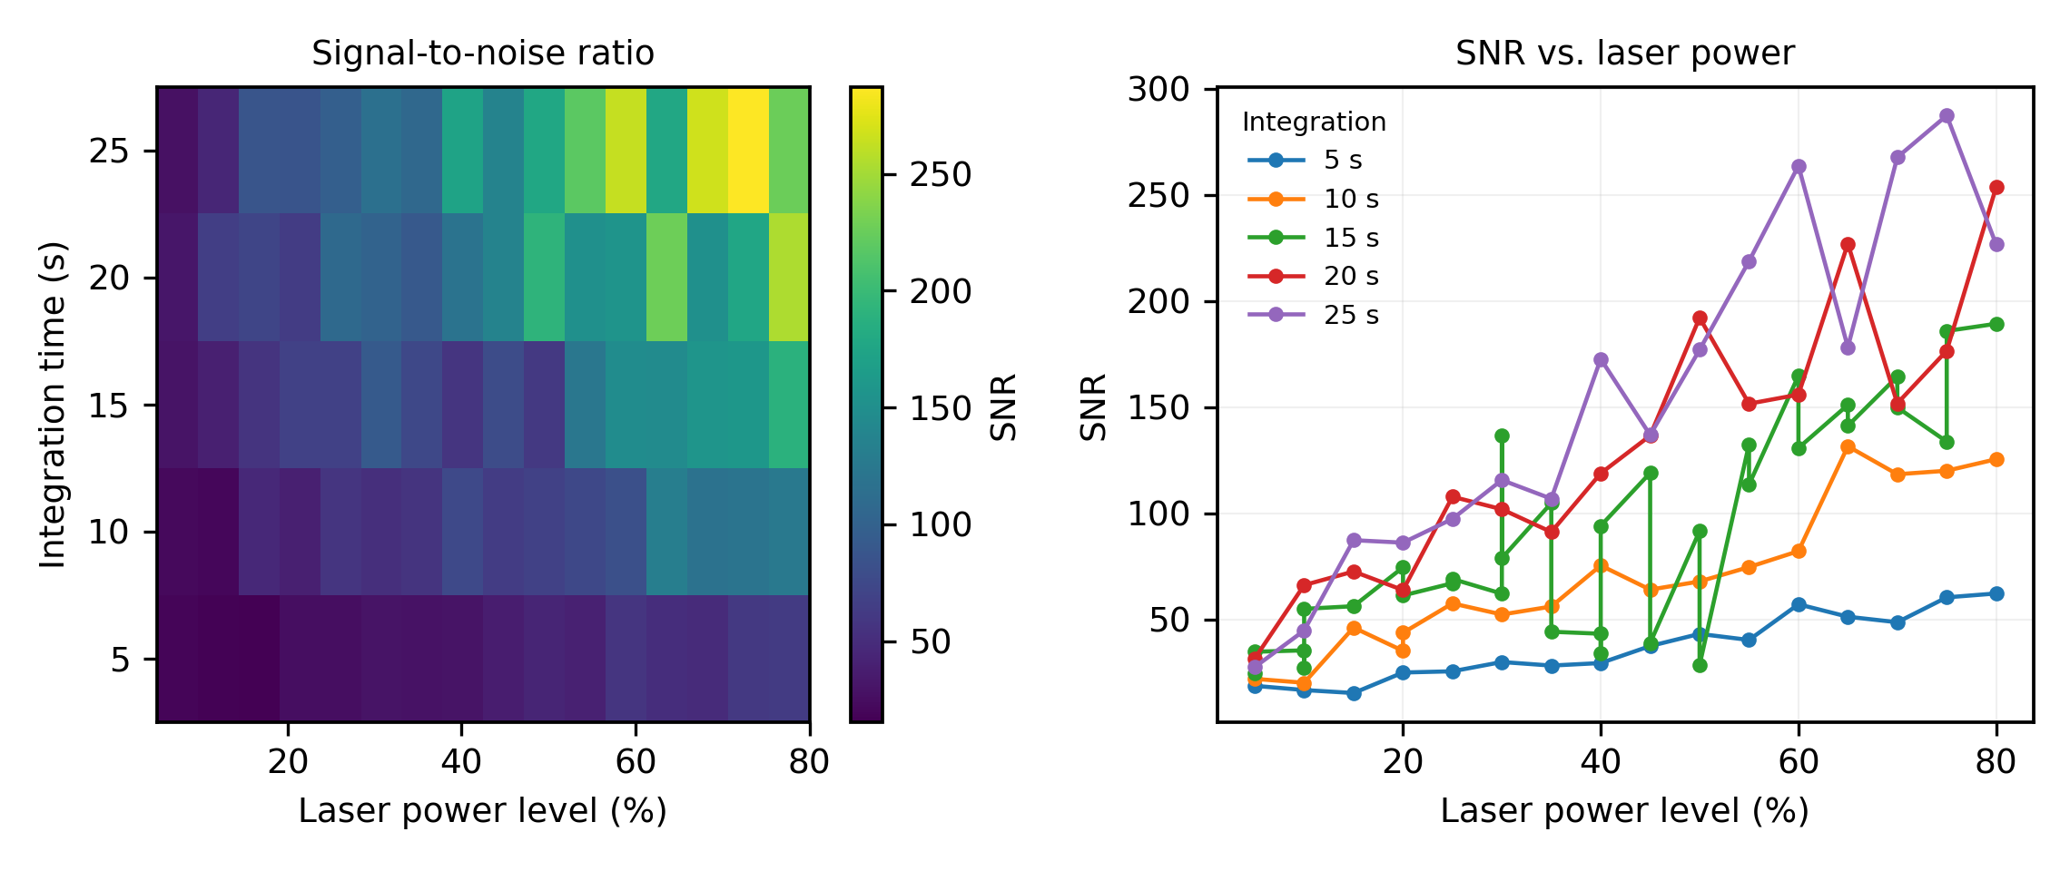
Figure 1. April acquisition-optimisation grid — signal quality vs. power and integration time.

2.2 NEW — May Replicate Set (104 spectra, 29–30 May)
Nine replicate sets at the settings the April grid identified as safe and high-quality, with a fresh sample spot for every measurement. This is the dataset all downstream analysis is built from: the reference spectrum used throughout this report is the mean of 22 independent replicates (sets R2 + R4), with per-point standard deviation.
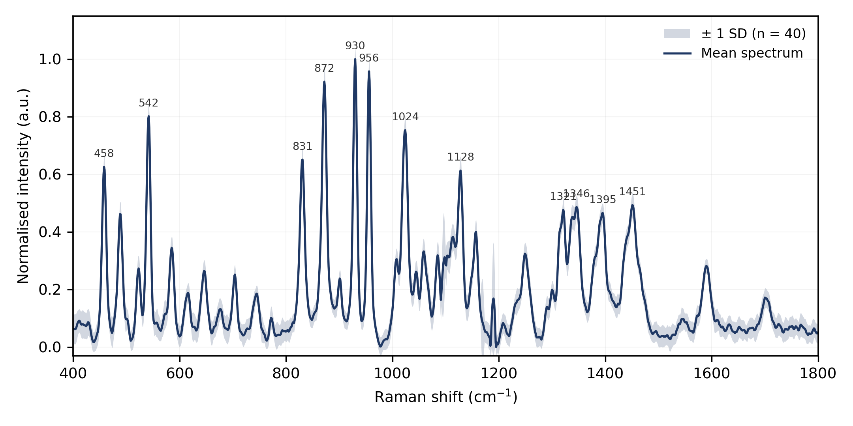
Figure 2. Reference experimental spectrum — mean of 22 replicate measurements (May), ±1 SD shaded.

2.3 Damage threshold, established from both sessions
Condition | Outcome
≤80% power, ≤25 s | safe
70% power, 30 s | safe (r = 0.977)
70% power, 60 s | safe (r = 0.970)
90% power, 30 s | safe (r = 0.948)
90% power, 60 s | SAMPLE DESTROYED — excluded from all analysis
Practical takeaway: the April grid answered “what setting is safe and readable,” and the May set is the actual data used for every scientific conclusion in this report. Neither supersedes the other — they answer different questions.

3. DFT Simulation — α-Anomer vs. β-Anomer
Two independent Gaussian 16 calculations exist for NAM: the β-anomer (used as the reference model throughout the manuscript) and the α-anomer (run specifically to test whether the anomeric form explains the 11 experimental bands the β model cannot match).
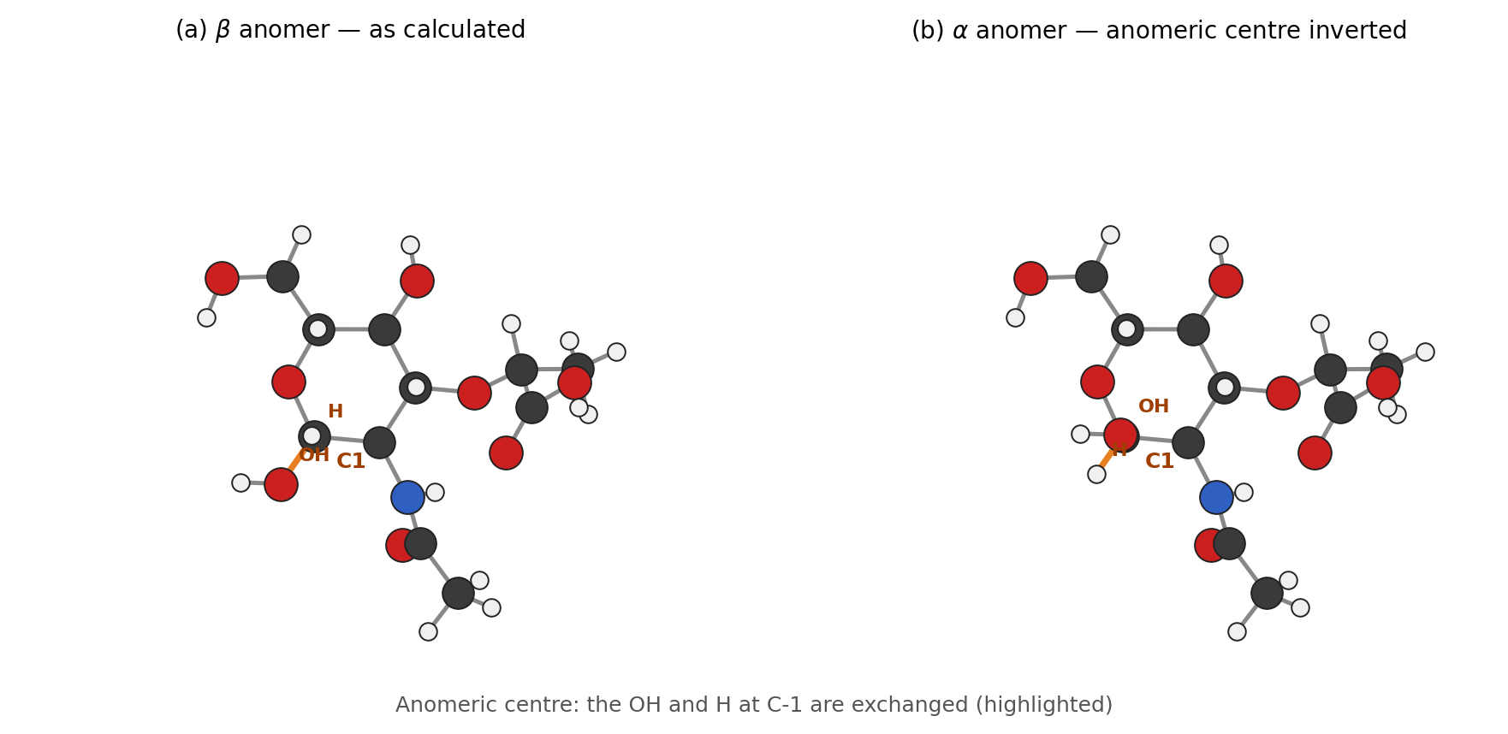
Figure 3. α-anomer vs. β-anomer optimised structures.

3.1 Both calculations are sound
- Identical method, basis (573 basis functions), and gas-phase treatment for both anomers.
- Both converged to a true minimum: 0 imaginary frequencies, normal termination.
- 111 normal modes computed for each, all with Raman activities.

3.2 The honest test — and why it fails
At first glance, the α-anomer appeared to match 5 of the 11 β-unmatched bands within ±18 cm⁻¹, including both bands (830, 956 cm⁻¹) the calculation was run to explain. This is misleading: those 11 bands are defined as the ones β failed to match, so β scores 0/11 on its own leftovers by construction — any second mode set will score above zero. The correct test is whether α improves the fit across all 41 bands more than a chemically meaningless control would.
Tolerance | β alone | α alone | β+α (real gain) | β+decoy (gain) | p-value
±5 | 16 | 14 | 23 (+7) | +7.22 ± 2.06 | 0.62
±8 | 23 | 19 | 29 (+6) | +4.94 ± 2.17 | 0.41
±10 | 25 | 25 | 30 (+5) | +5.02 ± 2.11 | 0.58
±18 | 30 | 31 | 35 (+5) | +4.28 ± 1.95 | 0.46
The control — the β modes shifted by a random offset, same count, chemically meaningless — scores just as well as the real α calculation at every tolerance tested. At no tolerance is the α improvement distinguishable from chance (p = 0.41–0.62). A ±18 cm⁻¹ tolerance with 111 modes in a 1400 cm⁻¹ window also covers 172% of the axis — wide enough that almost anything would match something.
Verdict: the α-anomer hypothesis is tested and rejected as an explanation for the unmatched bands. This is a real negative result, not a failed calculation.

3.3 Two of the five apparent α "matches" are physically unobservable
Exp (cm⁻¹) | α mode | Δ | Rel. intensity | Verdict
772 | 777.2 | +5.2 | 3.39% | credible
830 | 823.9 | −6.1 | 0.42% | too weak to observe
956 | 953.1 | −2.9 | 2.84% | credible
1517 | 1514.3 | −2.7 | 0.45% | too weak to observe
1785 | 1768.8 | −16.2 | 1.21% | marginal (Δ too large)
830 cm⁻¹ — one of the two bands the α calculation specifically targeted — is a strong experimental band (high confidence) but its candidate α mode carries only 0.42% of the calculated maximum intensity: that mode could not have produced an observable Raman line. The α-anomer does not explain 830 cm⁻¹.

3.4 What actually explains the unmatched bands
Neither anomer has any calculated mode between ≈1535 and ≈1720 cm⁻¹ — a roughly 190 cm⁻¹ gap. Experiment shows four clear bands inside it (1589, 1637, 1652, 1702 cm⁻¹). This is not an anomeric effect: it is the gas-phase, isolated-molecule approximation missing intermolecular hydrogen bonding to the amide and carboxyl carbonyls, which in the solid lowers those stretching frequencies by tens of cm⁻¹ into exactly that gap. This explanation accounts for the majority of the unmatched bands and applies to both anomers equally.
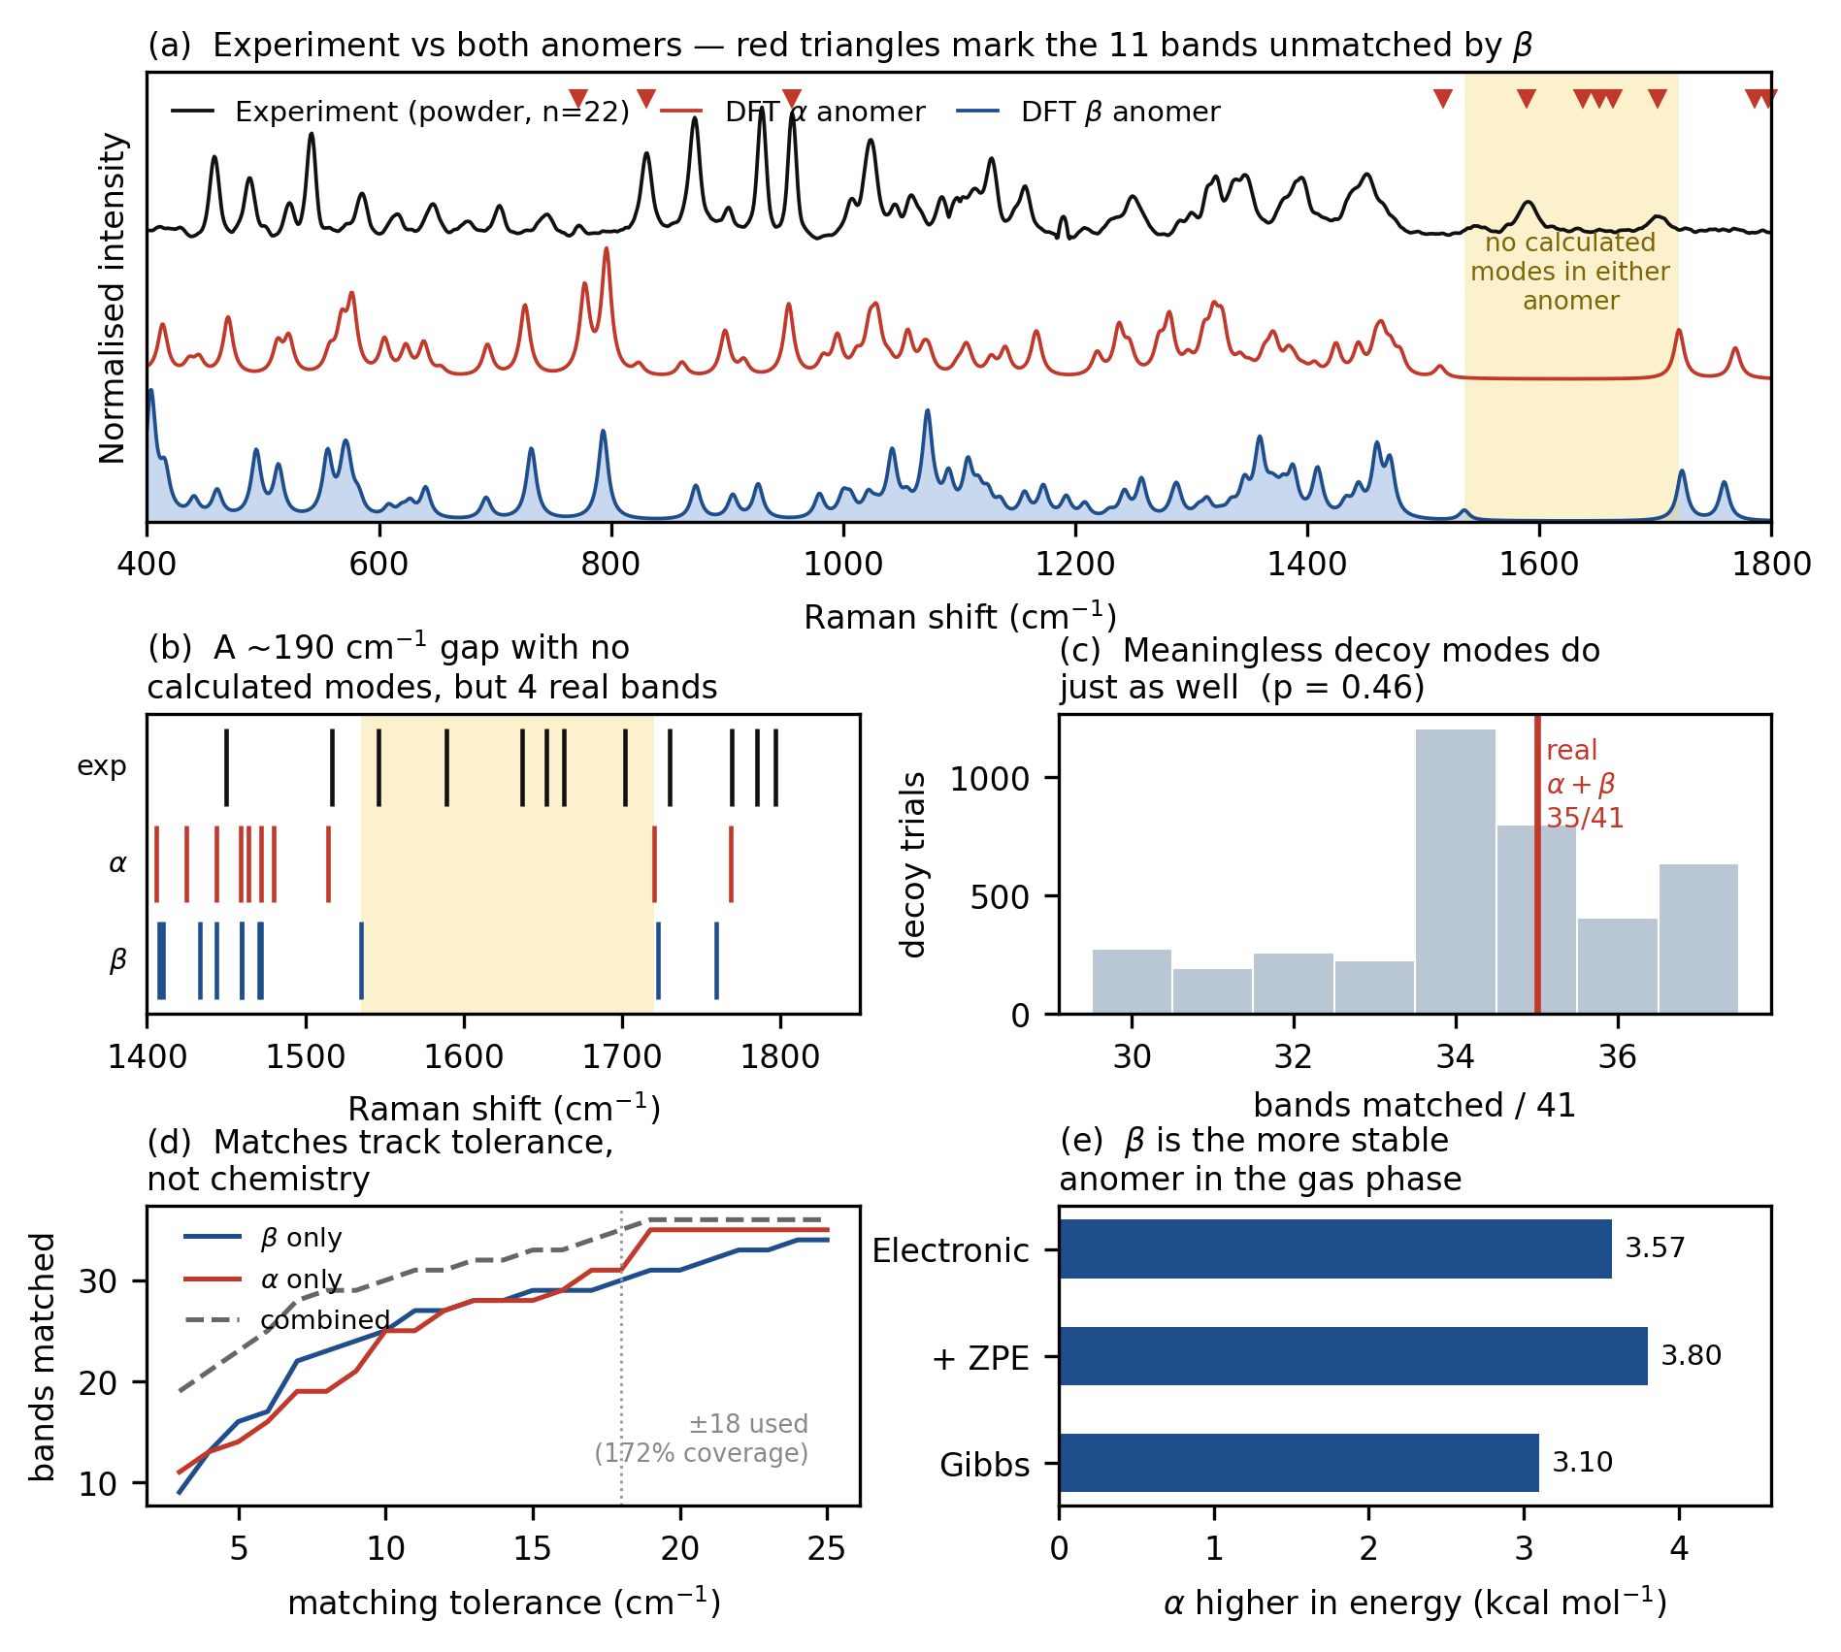
Figure 4. Five-panel summary of the α-anomer test: tolerance sensitivity, decoy control, and the unobservable-mode check.

3.5 β confirmed as the correct reference model
 | β | α | α − β
Electronic energy (Hartree) | −1087.570645 | −1087.564954 | +3.57 kcal/mol
+ ZPE | −1087.252763 | −1087.246711 | +3.80 kcal/mol
Gibbs free energy, 298.15 K | −1087.304371 | −1087.299425 | +3.10 kcal/mol
β is more thermodynamically stable in the gas phase and fits the experimental spectrum marginally better on its own (30 vs. 31 bands matched, but MAE 5.73 vs. 6.42 cm⁻¹). The manuscript's use of β as the reference model is justified on both counts — not merely assumed. Caveat: these are single conformers, not conformationally averaged, so the free-energy gap is indicative, not a rigorous anomeric equilibrium constant.
Data-quality note: two exp-vs-DFT comparison tables exist in the source archive and disagree — Table1_experiment_vs_DFT.csv (30/41 matched, used by the manuscript) vs. Experimental_vs_DFT_comparison.csv (33/41 matched, stale, differs by 1–2 cm⁻¹ on ≥12 rows). The manuscript is internally consistent; the stale file should be regenerated or removed so it doesn't contradict the paper if checked independently.

4. Powder Experimental Raman vs. DFT (β-Anomer)
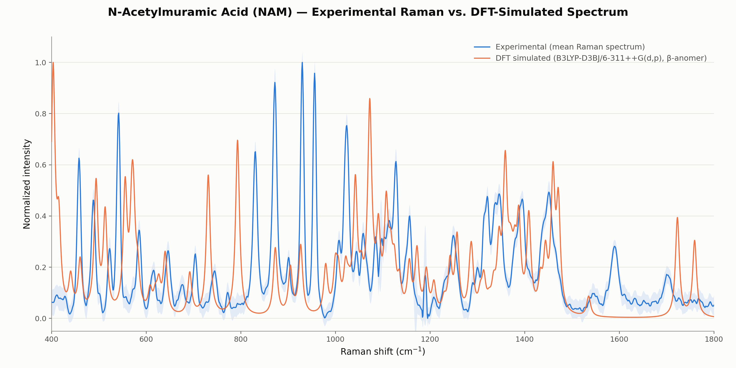
Figure 5. Experimental powder Raman overlaid on the β-anomer DFT simulation.
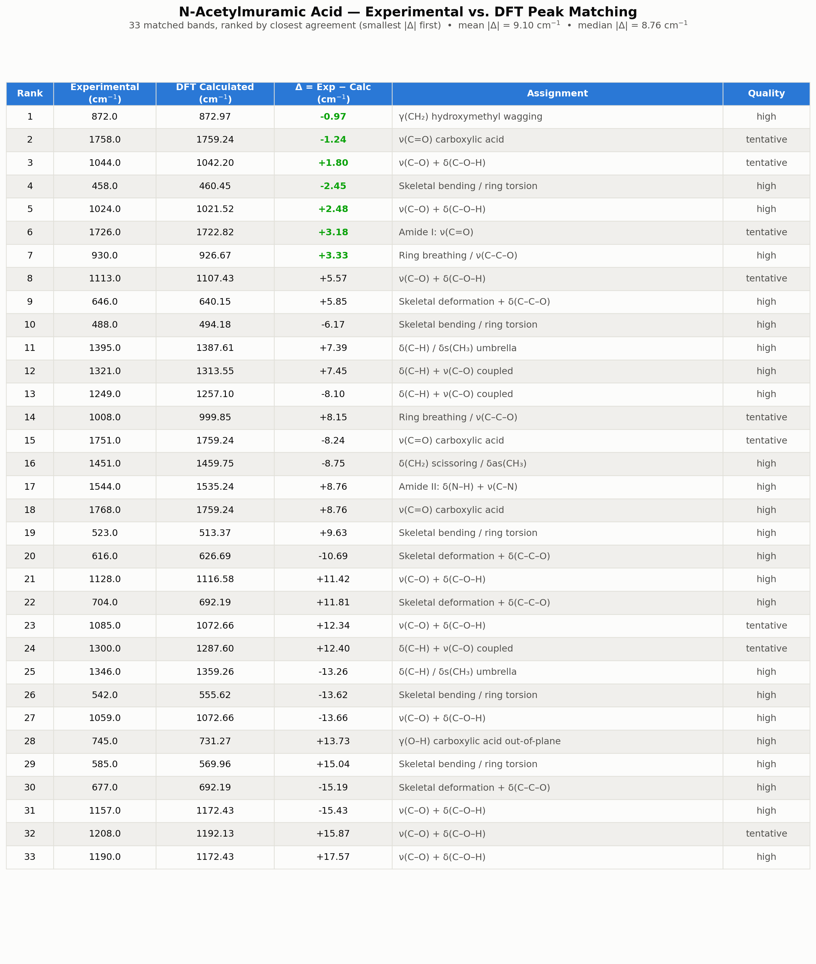
Figure 6. Peak-by-peak matches, ranked by closest agreement.
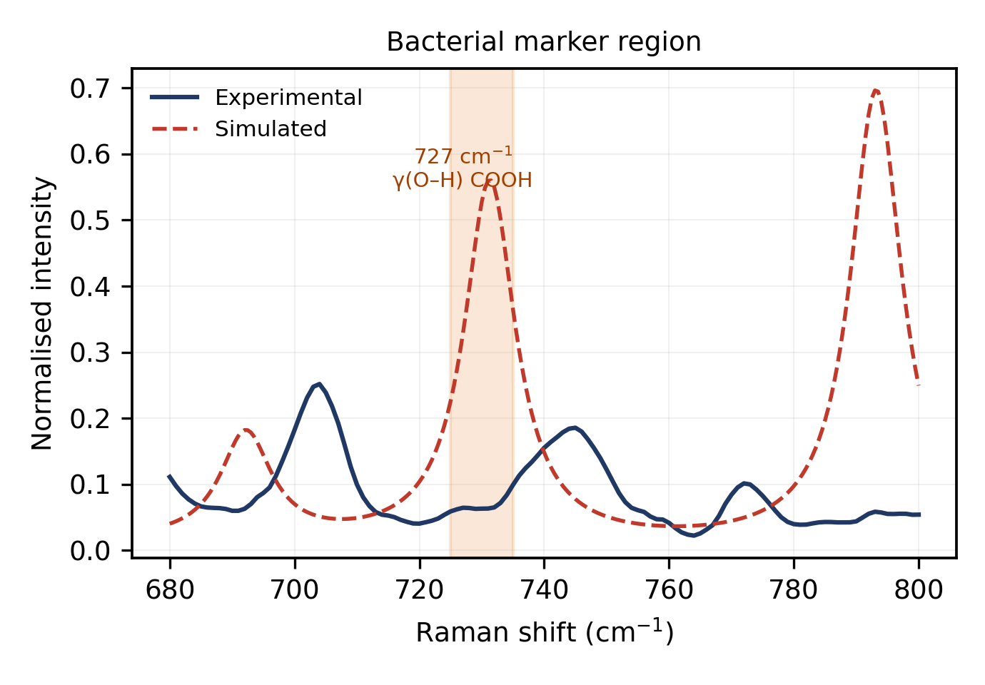
Figure 7. The 731 cm⁻¹ band in detail — assigned to out-of-plane carboxylic-acid O–H deformation (47.9% of displacement, only 0.5% pyranose-ring character), arguing against a muramic-acid origin for the bacterial 730 cm⁻¹ SERS marker band.

5. Comparison with Published Literature
Of two literature PDFs checked against the sample, only Kouach-Alix et al. (1994), J. Mol. Struct. 327, corresponds to NAM (crystalline, pure α-anomer); the other was excluded as not matching this compound. Its Table 7 Raman column was extracted with position-aware parsing (pdfplumber word coordinates, not flat text) to avoid column-shift errors from blank cells, and font-substitution artifacts in the B1/B2/B3 header labels were normalized before parsing.
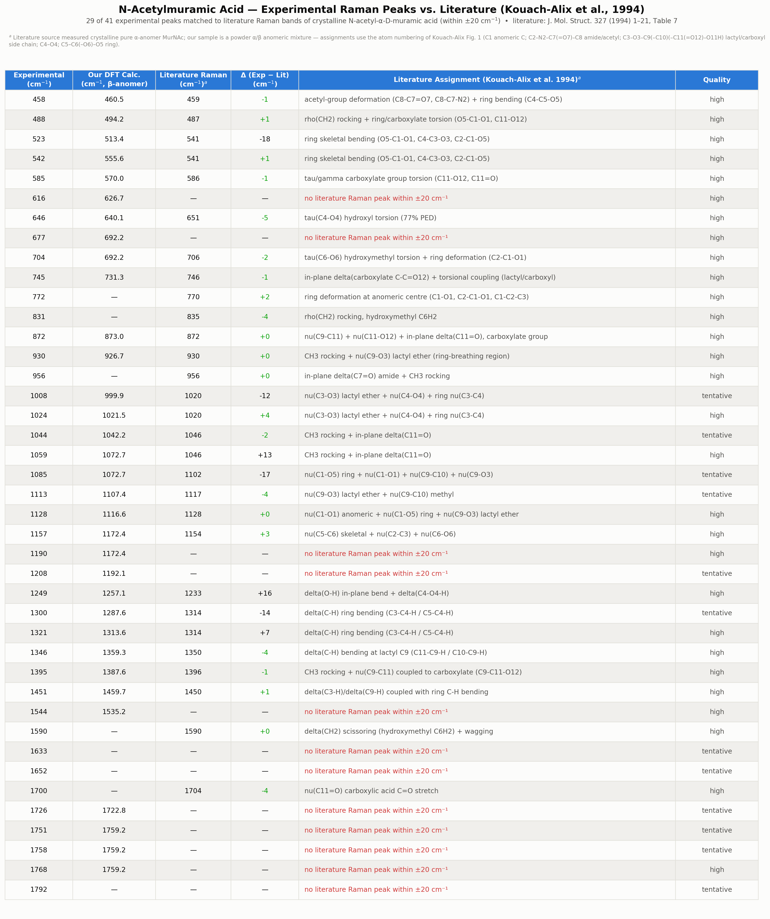
Figure 8. Experimental peaks matched to literature Raman bands (±20 cm⁻¹), Kouach-Alix et al. 1994.
Most bands find a literature counterpart within ±20 cm⁻¹; residual offsets are attributable to the literature sample being a pure crystalline α-anomer versus the present powder's α/β mixture.

6. SERS vs. Powder Raman
NAM SERS spectra (43 usable) were collected on a 2-minute HF/AgNO₃-etched Ag/Si substrate, selected via R6G calibration (mean SNR ≈343 at 2 min vs. ≈188 at 10 min vs. ≈38 at 5 min). The dominant SERS feature, ≈517 cm⁻¹ and roughly 4× any other peak, was confirmed — via a bare-Si reference — to be the silicon phonon line, not a NAM vibration, and excluded from all NAM peak lists.
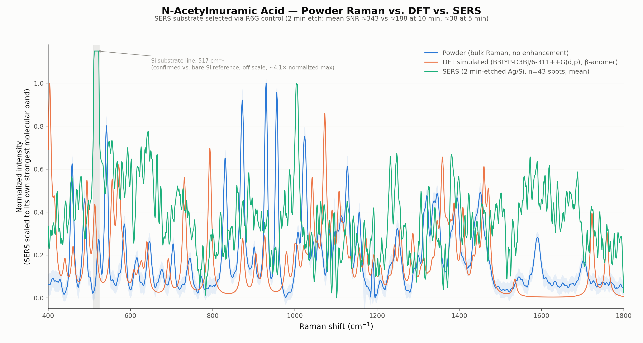
Figure 9. Powder, DFT, and SERS mean spectra overlaid (Si line masked).
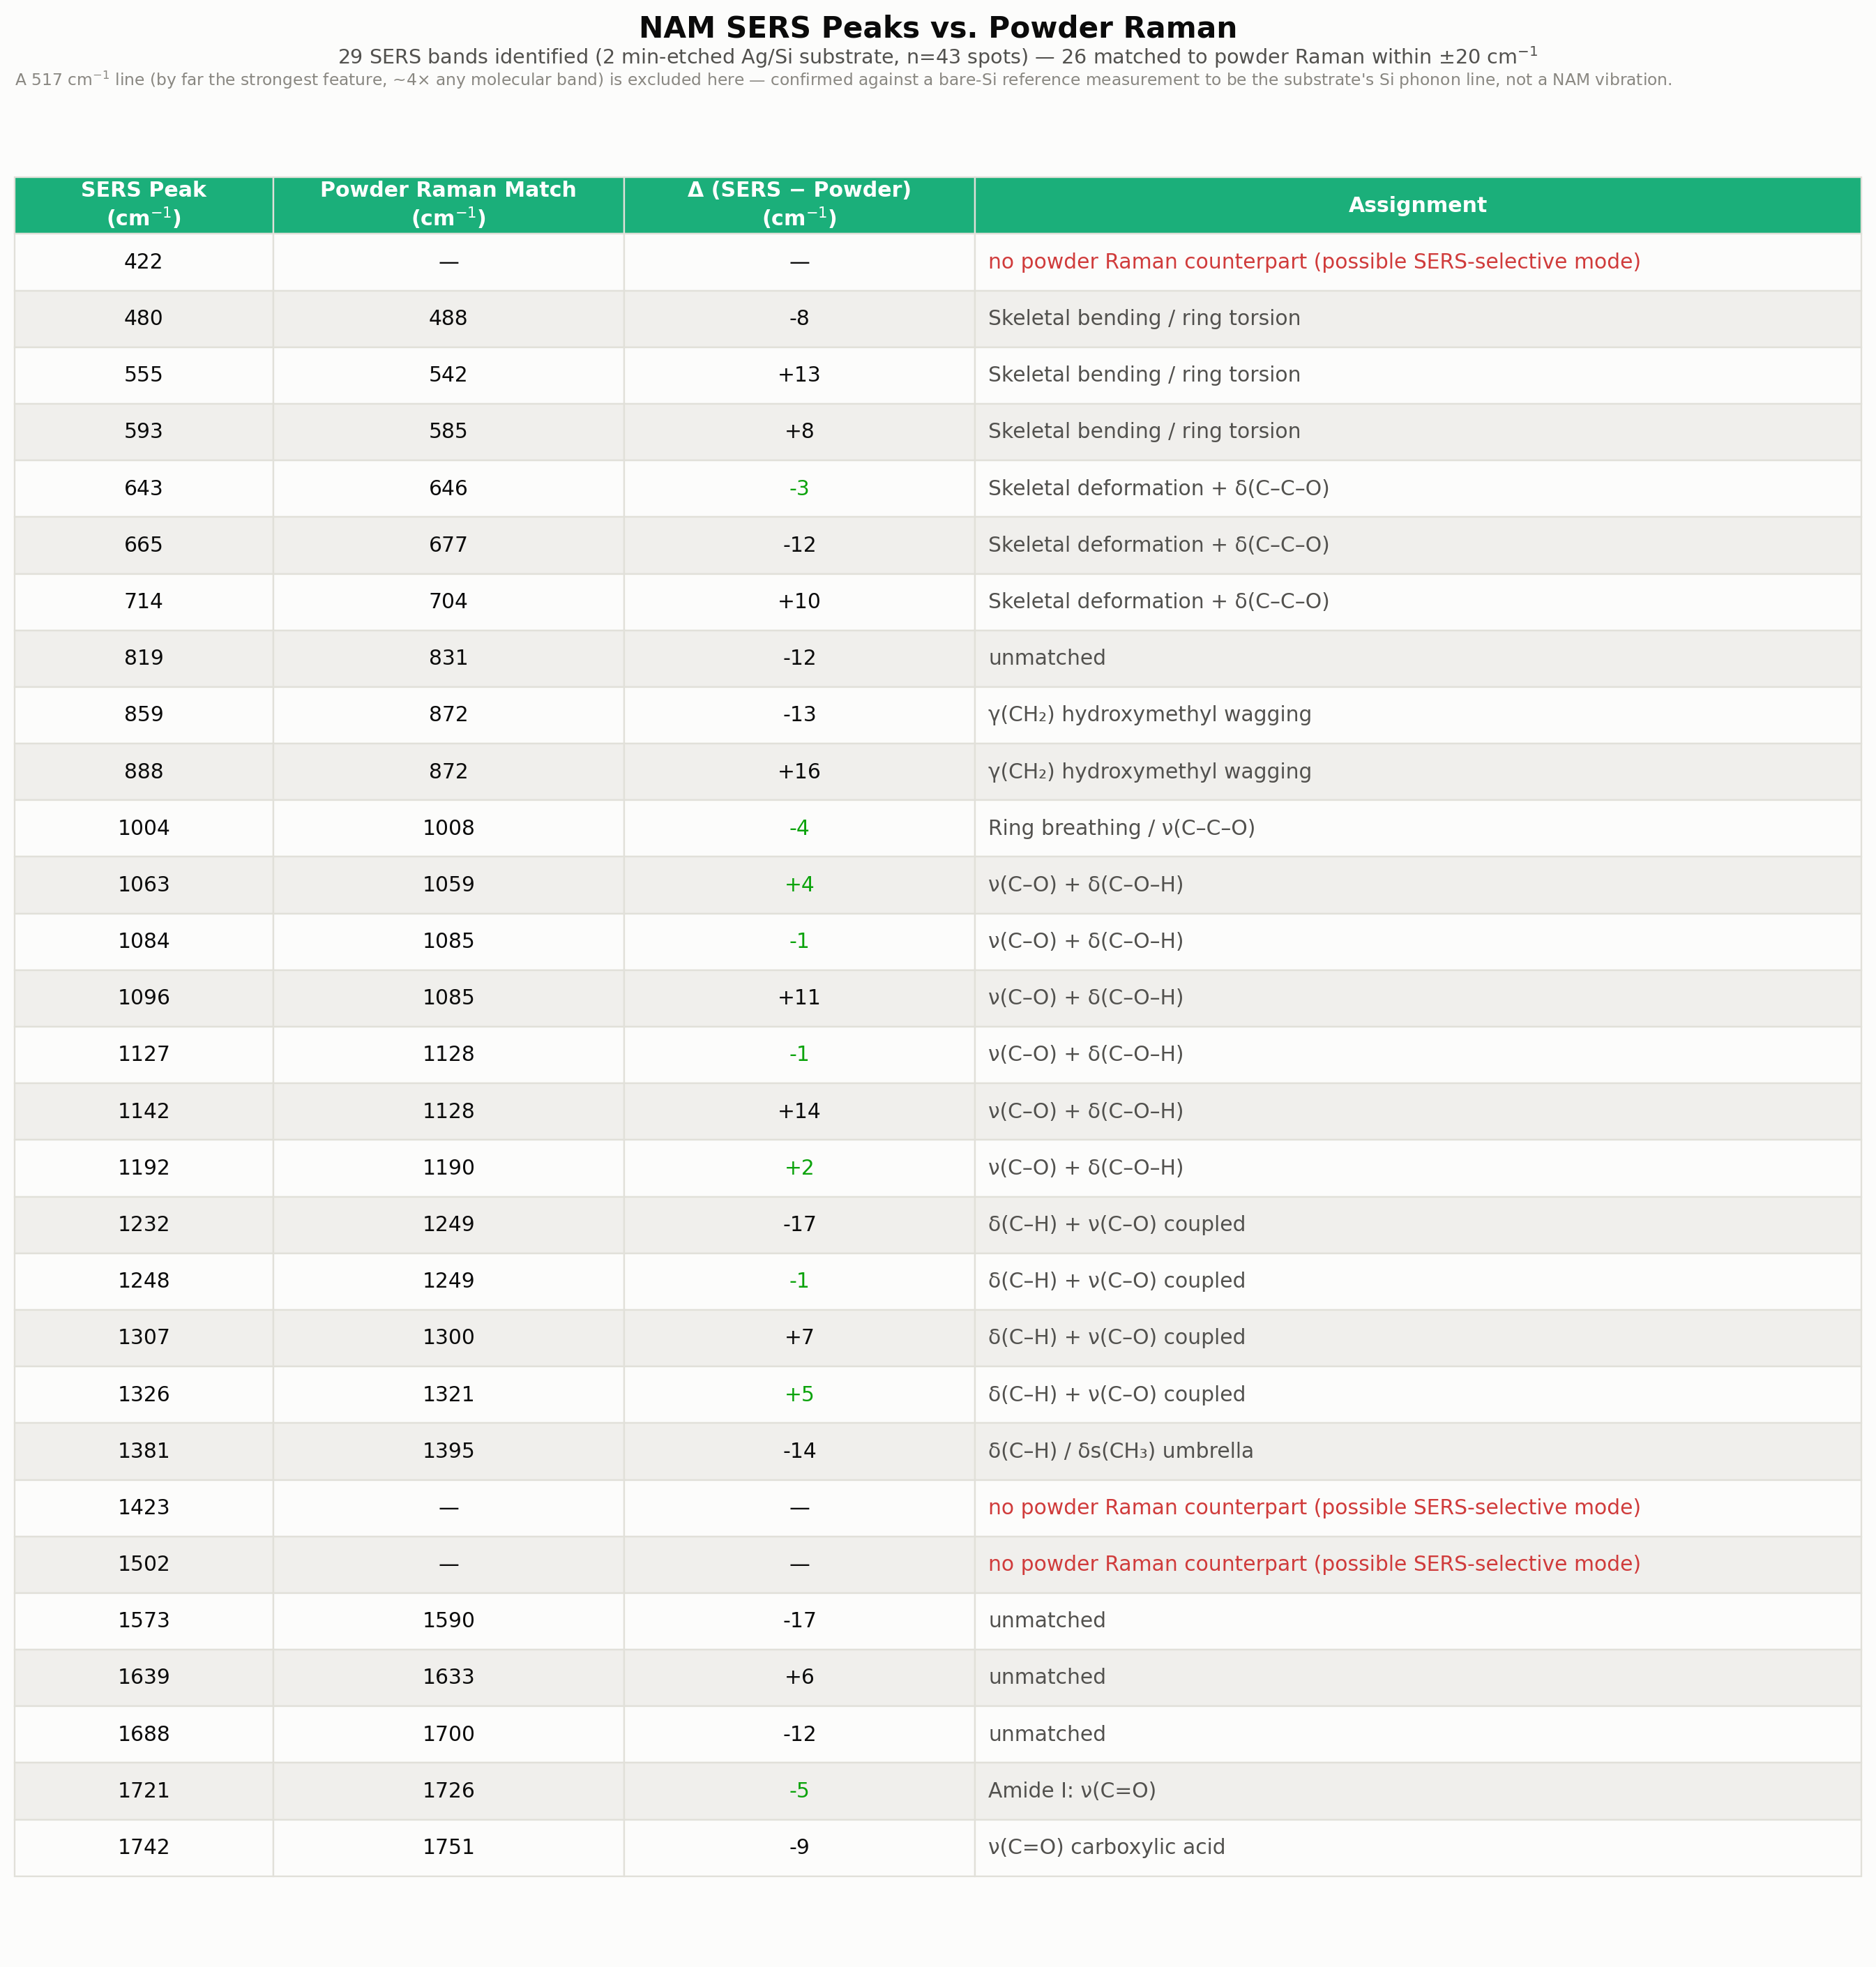
Figure 10. Candidate SERS peaks matched to powder bands (pre-validation).

7. SERS Signal Validation

7.1 Processing-stage transparency
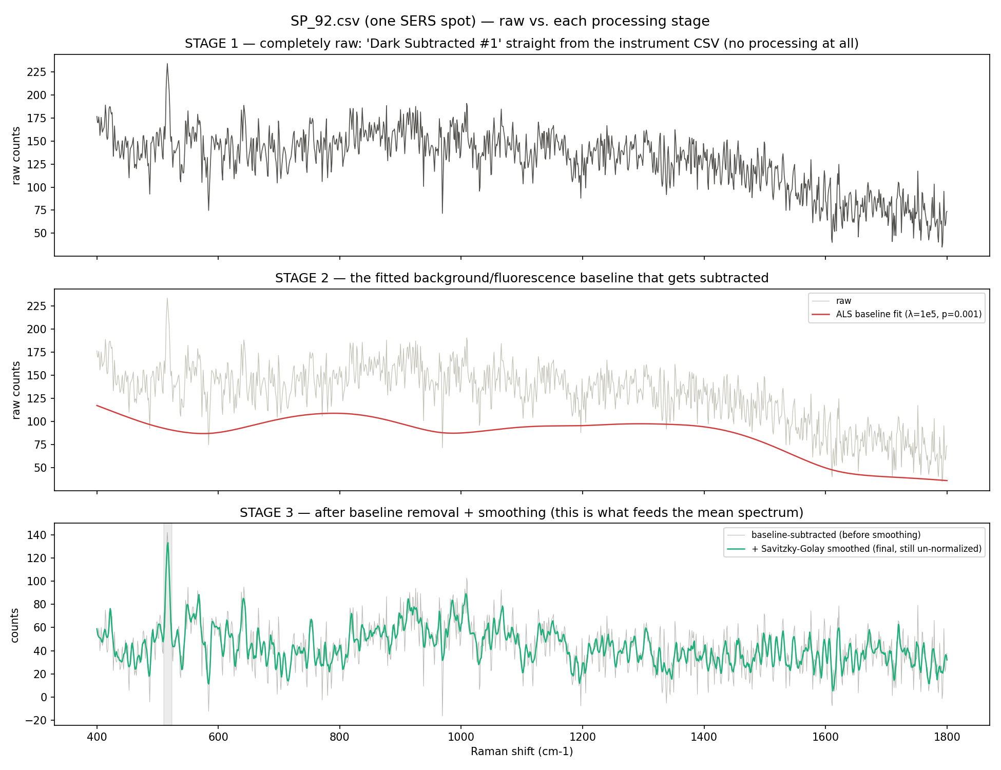
Figure 11. Raw → baseline fit → corrected & smoothed, for one representative SERS spectrum — confirming every reported result is post-processing, never raw.

7.2 Single-spectrum reproducibility
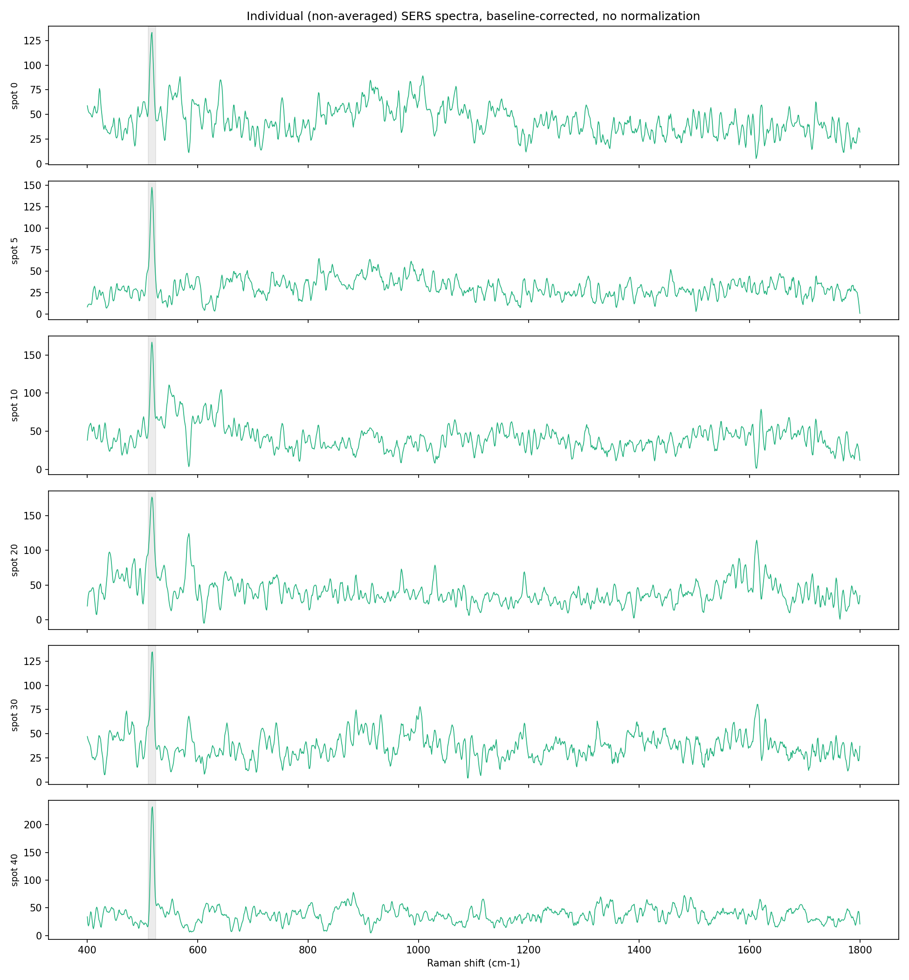
Figure 12. Six individual SERS spectra, illustrating typical single-spectrum noise character.

7.3 Blank-substrate comparison — mismatched etch (initial control)
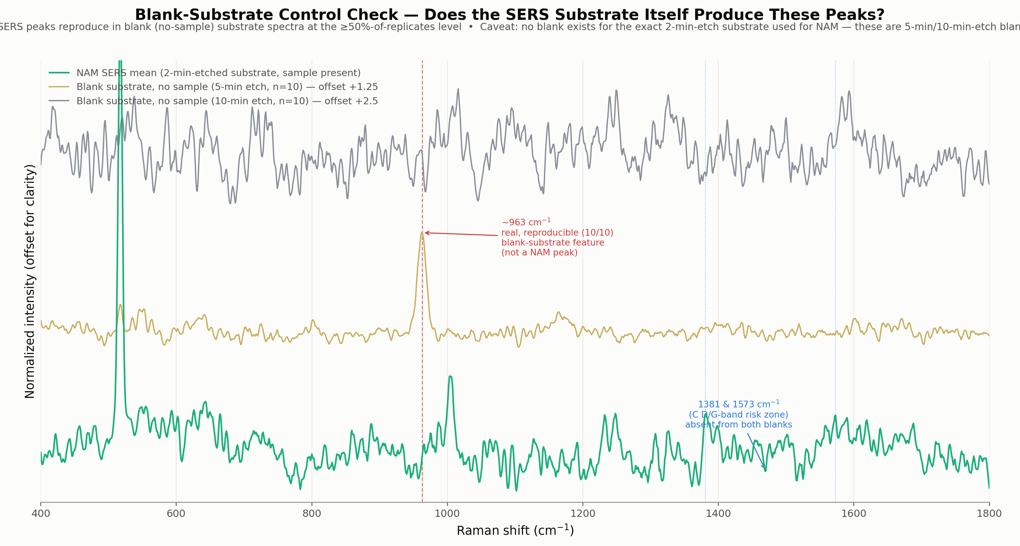
Figure 13. NAM SERS vs. 5-min/10-min-etched blanks — the closest control available at the time.

7.4 Blank-substrate comparison — true matched etch (decisive control)
A true matched blank was later located: 80 bare-Si spectra from two substrate pieces etched with the identical 2-minute recipe used for NAM, no sample present. Comparing directly against the 43 with-NAM spectra, using one consistent reproducibility rule for both:
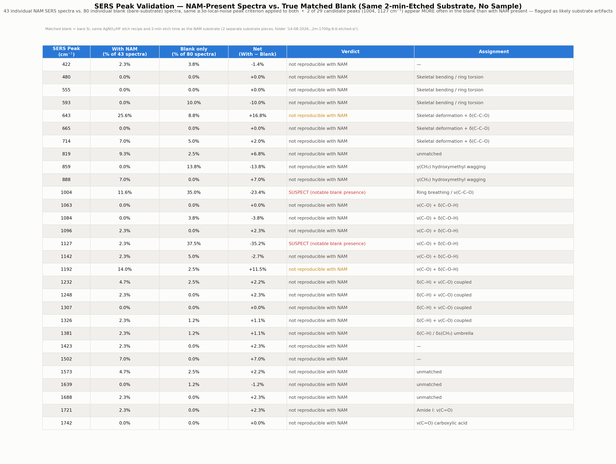
Figure 14. Per-peak comparison: fraction of spectra showing each candidate peak, with NAM vs. matched blank alone.
Two peaks — 1004 and 1127 cm⁻¹ — appear substantially more often in the blank (35.0%, 37.5%) than with NAM (11.6%, 2.3%) and are excluded as substrate artifacts. The two contamination-risk peaks (1381, 1573 cm⁻¹, near carbon D/G-band and citrate/nitrate regions) stay clean in both datasets. One peak, 643 cm⁻¹, shows a clear net-positive pattern (+16.8% vs. blank) — the single best-supported NAM SERS candidate.

8. Final Validated SERS Assessment
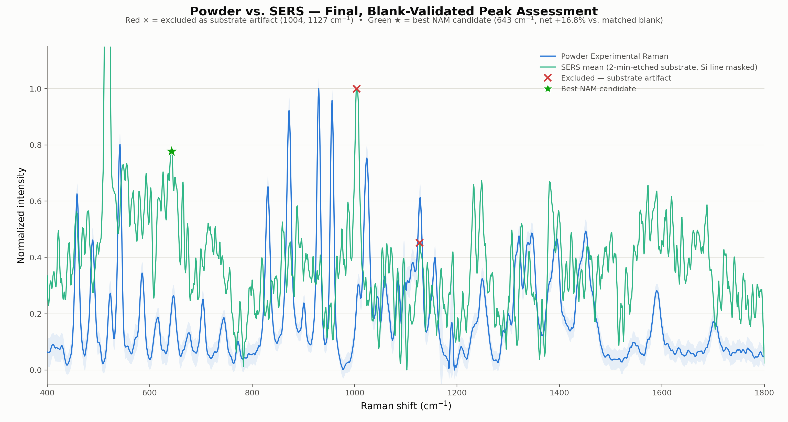
Figure 15. Powder vs. SERS, annotated with the final outcome (× = excluded substrate artifact, ★ = best NAM candidate).
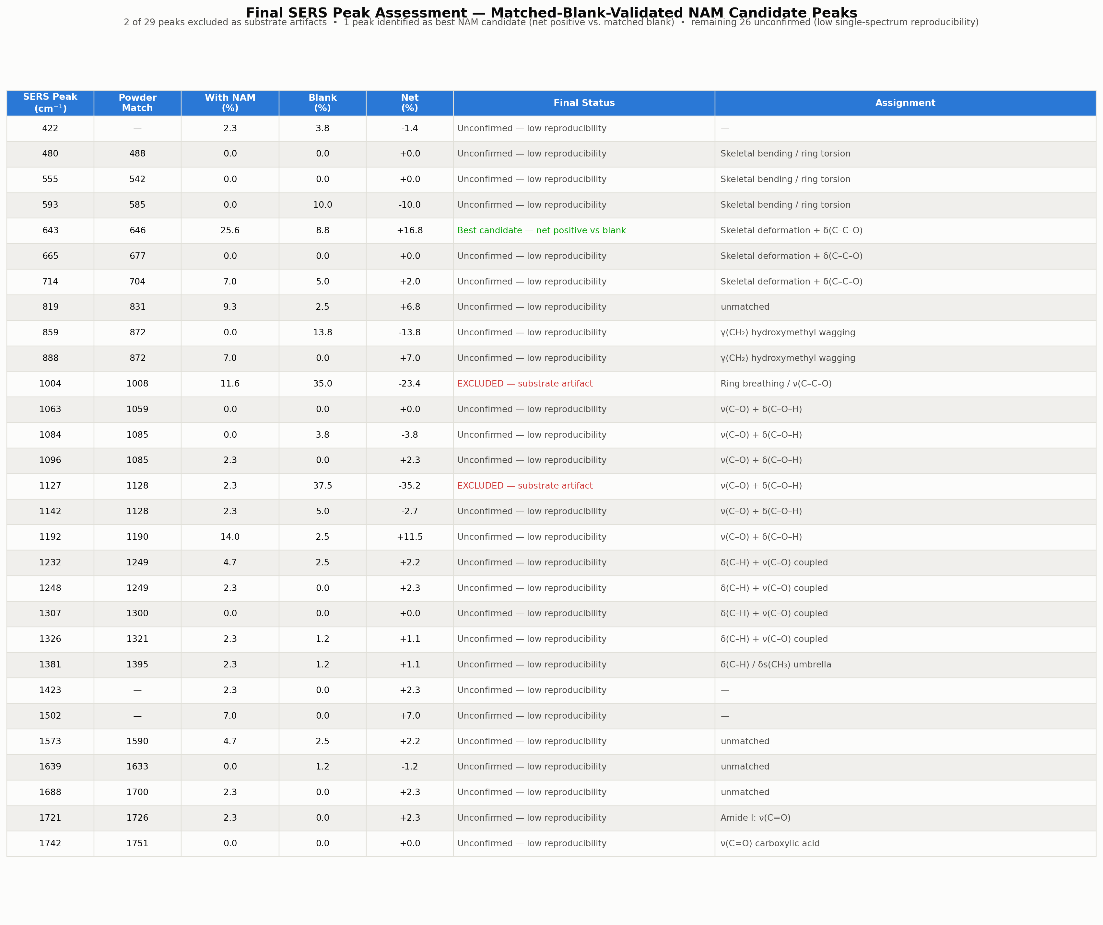
Figure 16. Final per-peak status for all 29 original SERS candidates.
Category | Count | Peaks / Notes
Excluded — substrate artifact | 2 | 1004, 1127 cm⁻¹
Best-supported NAM candidate | 1 | 643 cm⁻¹ (net +16.8% vs. matched blank)
Unconfirmed | 26 | Low single-spectrum reproducibility on both sides

9. Where Everything Now Lives
Every dataset referenced in this report — previously spread across four separate folders — has been consolidated into one folder, NAM_Master_Dataset, alongside the originals (nothing was deleted). It is organized as 19 numbered subfolders covering, in order: the old (April) and new (May) powder Raman data plus photostability, blanks and excluded runs; the processed powder results; the α-anomer and β-anomer DFT calculations and their comparison; the SERS R6G calibration, NAM measurements, matched and mismatched blank substrates, and bare-Si reference; and finally the analysis figures, this report, the manuscript, and the original analysis notebook. A full README with machine specs, folder-by-folder contents, and every data-quality caveat above lives at the top of that folder.

10. Summary of Conclusions and Caveats
- Powder Raman (May reference set) agrees closely with the β-anomer DFT simulation and independently with Kouach-Alix et al. (1994).
- The α-anomer DFT hypothesis for the unmatched bands is rejected with a proper statistical control; the residual gap is better explained by the gas-phase approximation missing solid-state hydrogen bonding.
- SERS's only unambiguous feature is the 517 cm⁻¹ Si phonon line. Of 29 candidate NAM SERS peaks, 2 are excluded as substrate artifacts, 1 (643 cm⁻¹) is the best-supported genuine candidate, and 26 remain unconfirmed rather than proven or disproven.
- Two data-quality issues are flagged for cleanup: a stale, disagreeing exp-vs-DFT comparison CSV in the original archive, and a mislabeled SERS subfolder name (“1m-etcheddata-” for what is actually the 2-minute-etch NAM dataset).
- Outstanding work: powder glass blanks at the actual measurement condition (70%/25s/5acc), a same-spot before/after SERS blank, a SERS concentration series, and a surface-selection-rule intensity check.

